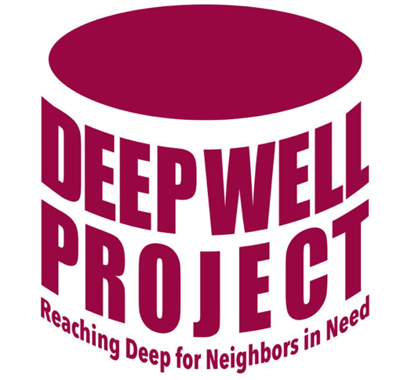
Deep Well Scholarship Application
For Students Attending Technical College of the Lowcountry
(Please print)

Please complete the application and submit with the following attachments:
- Proof of admission to Technical College of the Lowcountry (TCL)
- Copy of FAFSA Application or TCL financial aid award letter
- Copy of Class Schedule, if available
- Student ID Number

Full Name ___________________________________________ Birthdate ____/____/____

Home Address _______________________________________________________________

City _____________________ State _____ Zip Code _________ Email _________________

Marital Status _______________ Are you the Head of the Household? ___ Yes ___ No

Home Phone__________________ Cell Phone ____________________

Parents/Guardian ______________________________________________________________

Year graduated/graduating from High School _________ Or, Year obtained a GED__________

Are you the first in your family to attend college? Yes ____ No ____

Program of study you will be pursuing at TCL ________________________________________

What is your college goal? (Ex. - 2-year degree, certificate, 4-year degree) ________________
_____________________________________________________________________________

List your participation in other activities (school, community, church, etc) __________________
_____________________________________________________________________________
_____________________________________________________________________________
_____________________________________________________________________________

List any additional costs related to college that would be difficult for you to cover, such as transportation, gas, computer, child care, or other.
_____________________________________________________________________________
_____________________________________________________________________________
_____________________________________________________________________________
_____________________________________________________________________________
_____________________________________________________________________________
_____________________________________________________________________________

List jobs you have held in the last two years.
Employer Dates Hours per week
_____________________________________________________________________________
_____________________________________________________________________________
_____________________________________________________________________________

What goals/accomplishments have you set?
_____________________________________________________________________________
_____________________________________________________________________________
_____________________________________________________________________________
_____________________________________________________________________________
_____________________________________________________________________________

Explain why you would be an appropriate person to receive this scholarship.
_____________________________________________________________________________
_____________________________________________________________________________
_____________________________________________________________________________
_____________________________________________________________________________
_____________________________________________________________________________
_____________________________________________________________________________
_____________________________________________________________________________
_____________________________________________________________________________

To help us determine if and how much financial assistance you require, you will need to complete a financial need analysis form called a FAFSA (Free Application for Federal Student Aid). A FAFSA form can be obtained at the TCL Admissions Office or on the internet at FAFSA® Application | Federal Student Aid.

I confirm that the above information is accurate the best of my knowledge. I hereby acknowledge that my signature authorizes and gives full consent to Deep Well to utilize and publish any photographic, video, audio or digital images or recordings in which I appear in any form, including but not limited to newsletters, advertisements, promotional materials and social media, and I waive any claim to any royalties, proceeds or other benefits derived from the same. I further acknowledge and agree that I will abide by the terms and conditions of any grant award I may accept and receive.

Signature _____________________________________________ Date __________________

Please submit completed form at the Deep Well office at 80 Capital Drive, or mail it to The Deep Well Project, P.O. Box 5543, Hilton Head, 29938.

Revised 8/24/22

